Existing Holdings
13.21  10 Year Volatility^{[2]} | 8

[2]Portfolio future volatility is calculated as the standard deviation of the portfolio's simulated future values over a 10 year term using the portfolio's asset allocation. Simulated future values are based on stochastic simulations carried out with return, volatility and correlation projections for the underlying asset classes from Hymans Robertson.
[4] As a Growth investor you do not see yourself as a cautious person and are inclined to view risk as a source of opportunity rather than as a threat. If you have experience of investments and find financial matters fairly easy to understand then you may be suited to a Growth approach to investing. You may also be suited to this approach if you make investment decisions relatively quickly and are not usually particularly anxious about those decisions. As a Growth investor you typically look for higher returns rather than safer investments and understand that you need to take some risk to meet your investment goals.
Investment | Provider | % Invested
Vanguard Global Stock Index Fund Investor USD Accumulation (USD) | Vanguard Group (Ireland) Limited | 52.90
Vanguard Emerging Markets Stock Index Fund GBP Acc (GBP) | Vanguard Group (Ireland) Limited | 16.90
CT Emerging Market Bond Fund Z Income GBP (GBP) | Threadneedle Investment Services Ltd | 7.30
iShares Environment & Low Carbon Tilt Real Estate Index Fund (UK) D Acc (GBP) | BlackRock Fund Managers Limited | 7.90
Legal & General All Stocks Index Linked Gilt Index Trust I Class Accumulation (GBP) | Legal & General (Unit Trust Managers) Ltd | 7.70
Jupiter Gold & Silver Fund P2 GBP Acc (GBP) | Jupiter Asset Management (Europe) Limited | 3.90
CT UK Commercial Property Fund 1 Acc (GBP) | Columbia Threadneedle Fund Management Limited | 3.40

Asset allocation

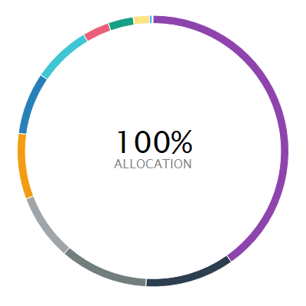 | ASSET ALLOCATION NET %⁽¹⁾ SHORT % LONG %  l North America Equity 40.21 0.00 40.21  l Global Property 10.64 0.00 10.64  l Emerging Markets Equity 10.52 0.00 10.52  l Global (ex-UK) Fixed Income 7.90 -0.74 8.64  l Developed Pacific (ex-Japan) Equity 7.83 0.00 7.83  l UK Index Linked Bonds 7.39 0.00 7.39  l Europe (ex-UK) Equity 6.97 0.00 6.97  l Commodities 3.18 0.00 3.18  l Japan Equity 3.01 0.00 3.01  l UK Equity 1.95 0.00 1.95  l Cash - Short Term Money Market 0.30 -0.01 0.31  l Other 0.10 0.00 0.10
⁽¹⁾ Due to rounding there may be a discrepancy between the Long/Short % and the Net %.

